**Introduction to JavaScript**

**LAB # 10**



**Spring 2022**

**Computer Fundamental**

Submitted by: **Muhammad Sadeeq**

Registration No : **21PWCSE2028**

Class Section: **C**

“On my honor, as student of University of Engineering and Technology, I have neither given nor received unauthorized assistance on this academic work.”

Student Signature: _*Muhammad**Sadeeq****__***

Submitted to:

**Engr. Abdullah Hamid**

(13-March-2022)

Department of Computer Systems Engineering

University of Engineering and Technology, Peshawar

Lab 10:

**Introduction to JavaScript**

**Lab Tasks:**

Make a webpage according to the diagram in the image below

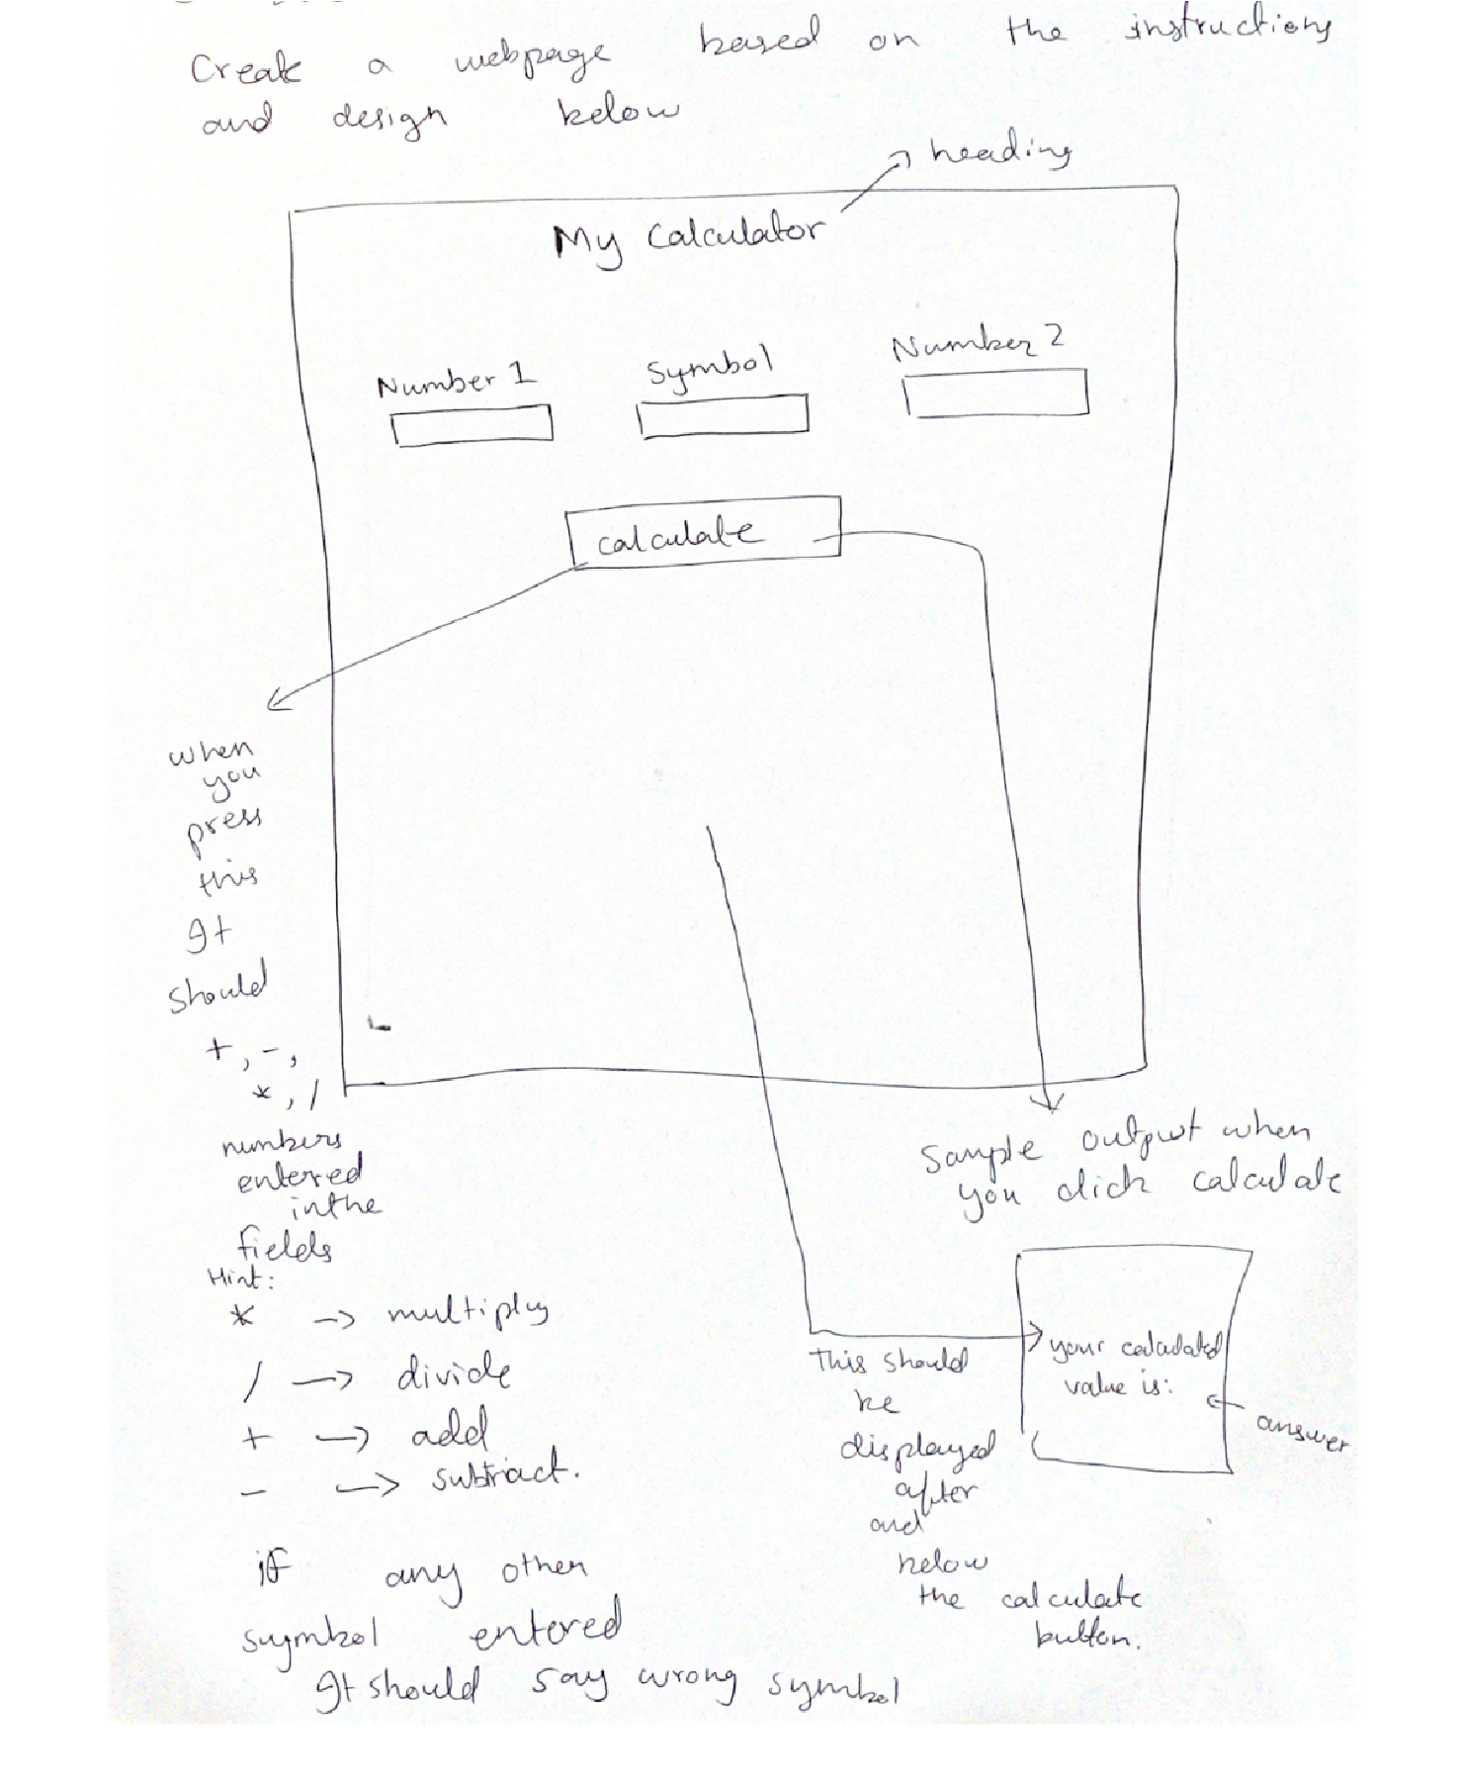

**NOTE: This Lab task should be uploaded as an HTML FILE. The Picture(s) (if you have used any) should also be uploaded so that I could check it properly.**

HTML OUTPUT

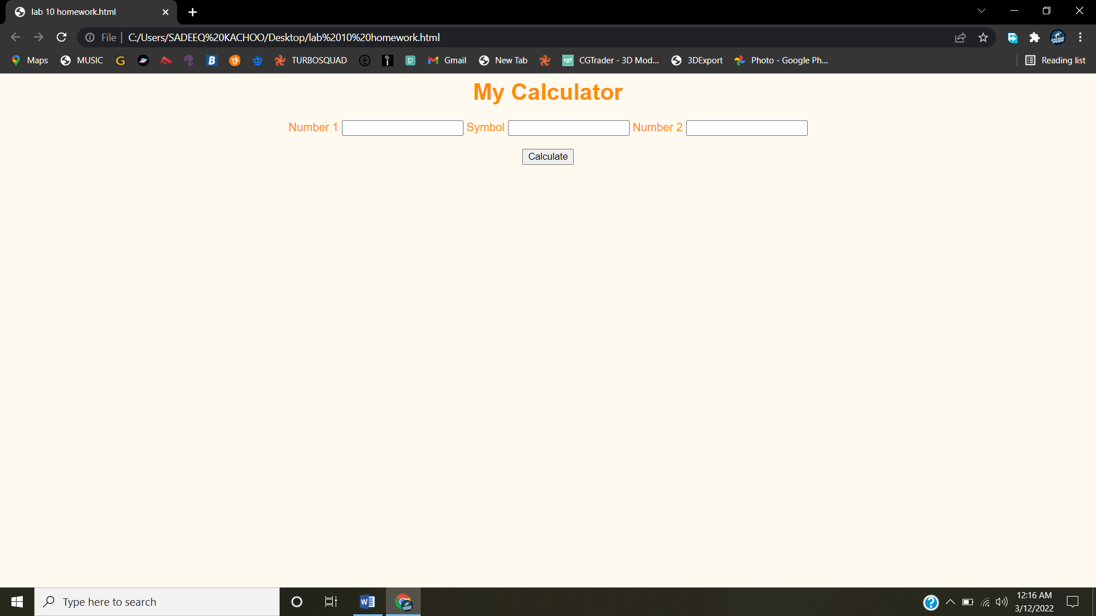

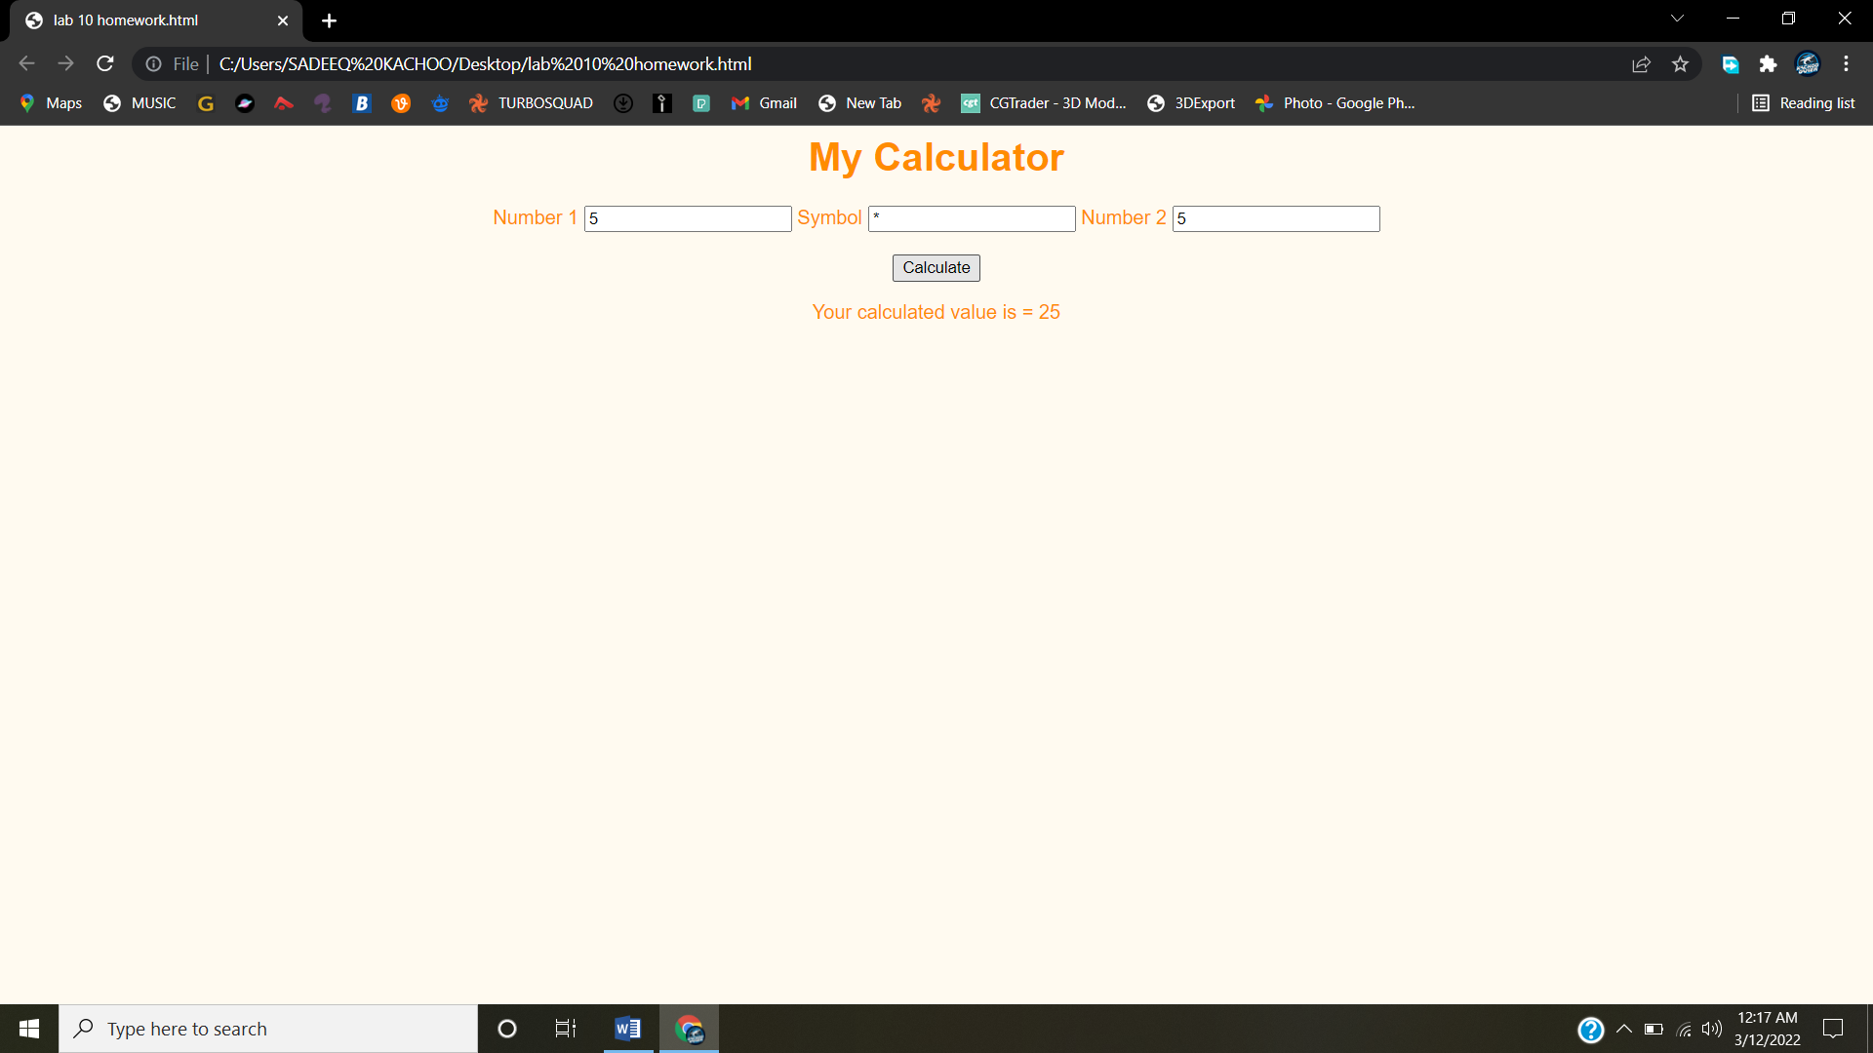

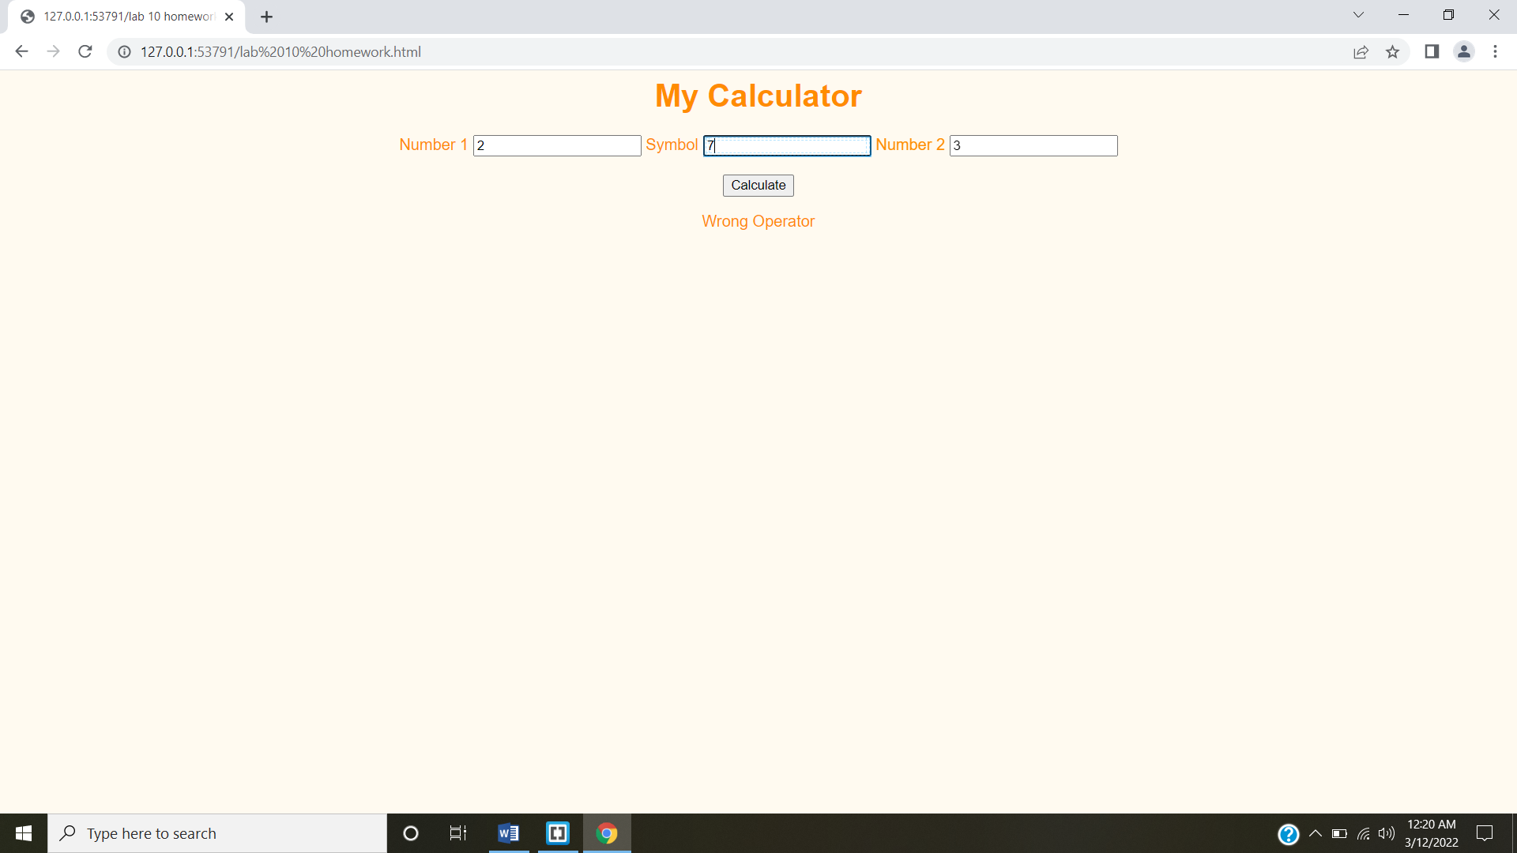

HTML CODE

